ONLINE STUDY INSTRUCTIONS FOR INTERNATIONAL STUDENTS
1. In order to be able to use Belgorod State University information systems, activate your Intranet user account at https://www.bsu.edu.ru/bsu/ as follows:
- In the menu on the main website page, choose “Студентам” (For Students):
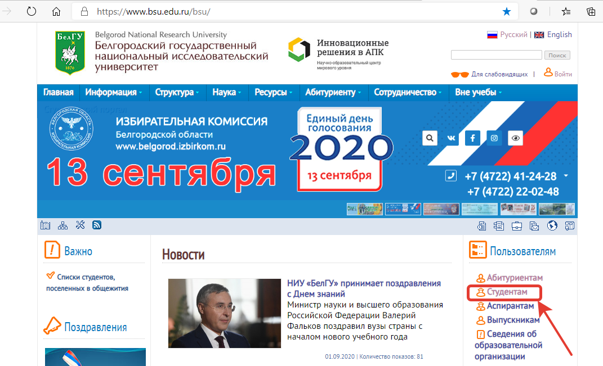

- Proceed to activate your account:
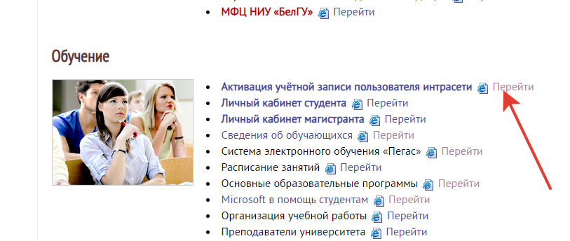

- Enter your data as follows:
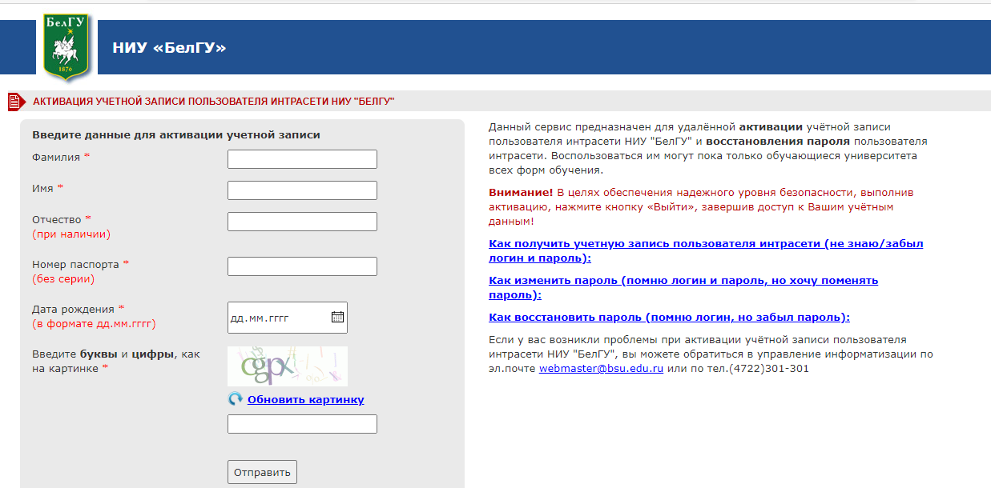
Фамилия – (Enter your surname)
Имя – (Enter your name)
Отчество (при наличии) – (Enter your patronymic, if any)
Номер паспорта (без серии) – (Enter your passport number, do not specify passport series)
Дата рождения (в формате дд.мм.гггг) – Date of birth (day, month, year)
Введите буквы и цифры, как на картинке – Enter the letters and figures as you see them in the picture
Attention!!!! The above data must be filled in IN RUSSIAN. Spell the words exactly as they are provided in the certified translation of your documents into Russian.
Once you have created and activated your account, you will use it as the access key to the University e-mail, personal space, electronic study resources etc. There is a single identification system for all the University information systems, that is why you will use the same login and password in order to access them.
3. Once you have activated your Intranet user account, the University’s e-learning systems will become available for you. Pegas e-learning system located at https://pegas.bsu.edu.ru/ contains educational resources and assignments for the subjects you study. Using Pegas, you will read the theoretical information that your teacher has placed online, on a self-study basis. You will also do tests in order to check how well you have digested the information; you will do practical assignments and laboratory assignments and then submit your answers, so that they can be checked by the teacher. If you need any help, you can contact the leading teachers in the forum or by message. Webinars must be attended online, according to the time-table. You may also use these resources to communicate with your group-mates and to contact technical support.
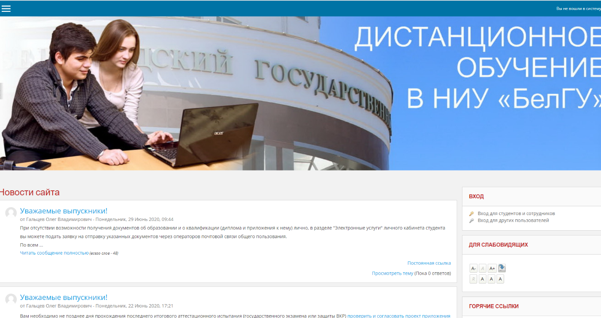
You can choose interface language in Pegas:
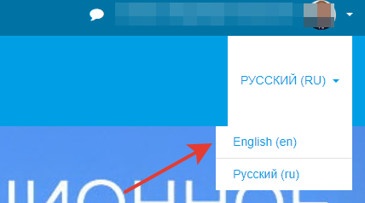

5. To access your online course in Pegas, press the name of the academic subject in the electronic time-table of your group: https://www.bsu.edu.ru/bsu/resource/schedule/groups/.
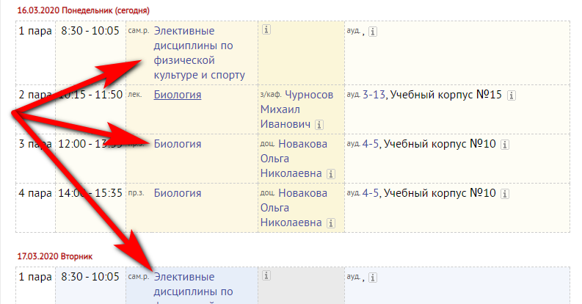

or you can find the necessary course in Pegas, in “My courses” section, after you have activated your account.
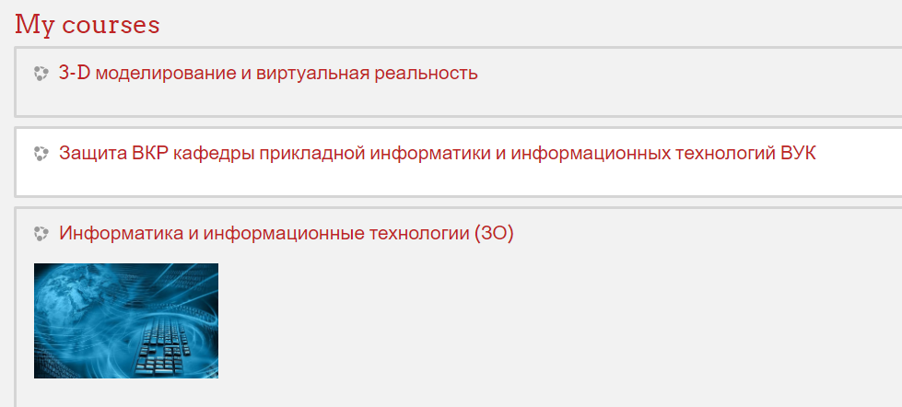

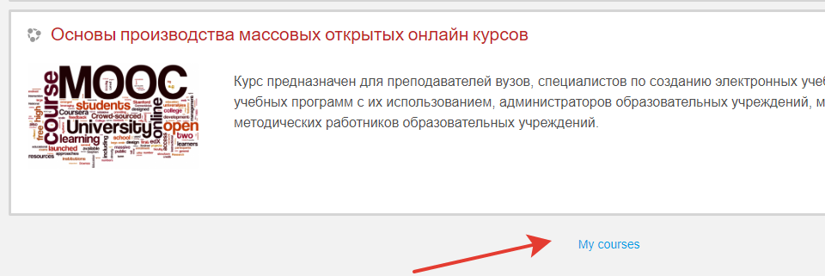
6. According to your teacher’s instructions, you can study new theoretical materials, answer questions, do tests and creative assignments and submit answers. If you have any questions, there are various ways to ask them.
“Messages” section in Pegas.
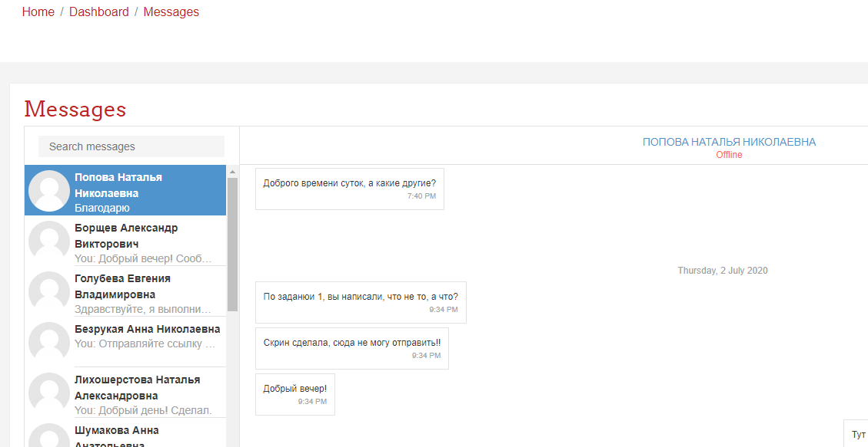
Discussion in the Forum section of the online-course
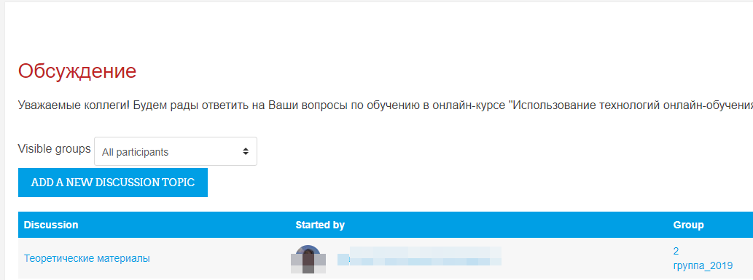
If your teacher has made an online appointment, use the BigBlueButton (marked as) in order to join a web conference.
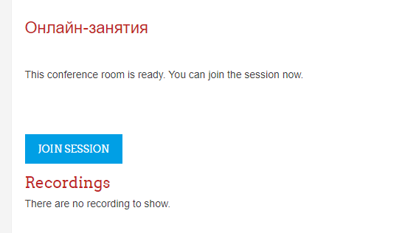
In the video-conference, teachers and lecturers can show presentations, explain new information and conduct webinars. You can ask questions in the chat or via a microphone. And if you and your group-mates have web-cams, teachers and lecturers will be able to see you as well. By the way, we have added a new feature which allows you to join video-conferences using mobile devices.
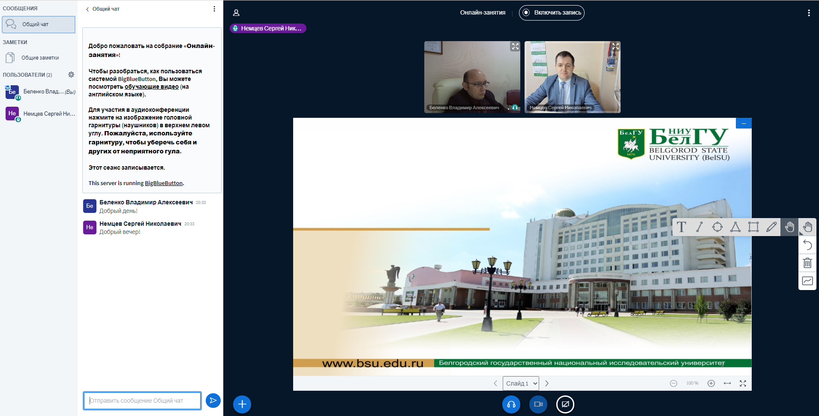
For this purpose, your PC or smartphone browsers must be updated.
7. You can use the University’s corporate e-mail to contact the University staff, teachers and students (http://mail.bsu.edu.ru/). Just enter your login and password. You already know that all BelSU information systems have the same identification system. This is why your login and password is the access key to all these systems.
8. Another information system you will use in your studying is “ИнфоБелГУ: Учебный процесс” (“The educational process”) located at http://dekanat.bsu.edu.ru/. Your personal space is located in this system, where you will load your portfolio. Besides, you will be able to find your group number and see your electronic record book. The “Electronic services” section is also located here. You can order certificates and documents, find services for students studying on a fee-paying basis and those staying in the hostels, as well as the University’s scientific library services.
9. The “Help for students” section contains instructions on how to use the information systems.
